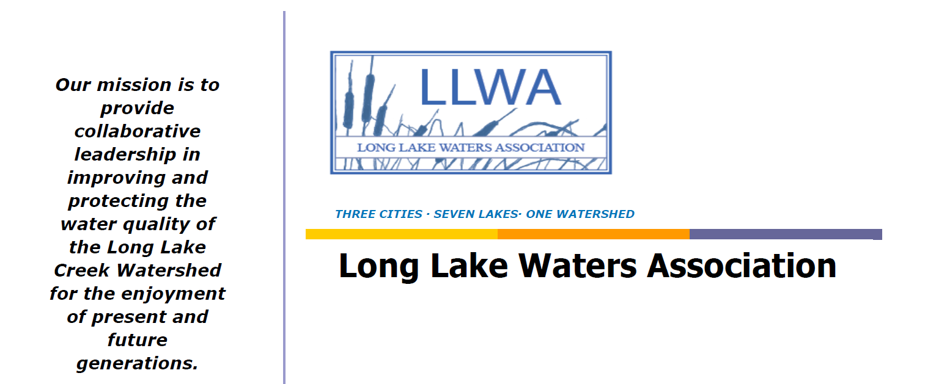

Long Lake Watershed: Long Lake Creek Watershed, just west of Minneapolis, Minnesota, covers over 7,619 acres. It is a headwater for Lake Minnetonka and Minnehaha Creek, which in turn flows into the Mississippi River and the Gulf of Mexico. The Long Lake Watershed includes seven Minnesota lakes (School, Holy Name, Lydiard, Wolsfeld, Dickey's, Long Lake and Tanager Lake on Lake Minnetonka), as well as all of the surrounding streams and wetlands. It encompasses three cities (Medina, Orono and Long Lake, MN) and over 6,000 households.

The problem: The Long Lake Watershed water quality is very poor, due to years of agricultural run-off and degradation by invasive species such as carp. Specifically, five of the seven lakes in the watershed are identified by the MCPA as "impaired for excess nutrients" (the other two have not been tested), and DNR Fish monitoring shows "high" mercury levels (i.e., in excess of established state safety limits for consumption. Water quality in Long Lake is currently rated "D" by the MPCA, and there are frequent beach closing due to Blue Green Algae and Ecoli.

Long Lake Waters Association: The non-profit Long Lake Waters Association was founded in 2016 by community members as a grassroots group to address the poor water quality within the watershed. LLWA works collaboratively with non-profits, government agencies, and the communities and three cities surrounding the watershed to help drive understanding of the relationship between the lake and the surrounding landscape, and to develop effective strategies to improve water quality in Long Lake and its watershed. We have three main strategic goals: (1) Improving the Water Quality, (2) Engaging Citizen Scientists, and (3) Educating the Community.

Improving Water Quality: One of the primary means to improve water quality within the watershed is via carp removal. In 2017, LLWA launched an exciting 3-year project to radio track the migration of carp throughout the seasons, including under-ice winter movement, within the watershed in order to best understand and then be able to reduce the population. Students from the local middle school and other community members were able to participate in the electrofishing and tagging of the carp. The data from that project allowed us to work with the Minnehaha Creek Watershed District (MCWD) to pursue and obtain a BSWR (MN Board of Soil and Water Resources) grant for $112,000 to identify strategies that would improve water quality in the watershed. With this grant, we were able to RFID tag and then track via solar powered monitors the ingress/egress and movement of carp within the watershed, ultimately allowing us to conduct a successful box-netting effort this summer. Working with an outside vendor, we were able to corn bait two identified locations (with 100 pounds of corn a night!) to attract carp, essentially "training" them to go to designated locations for the food. After a week of "training," we were able to extract over 1000 carp over several different midnight net catches. The carp were mostly over 22 inches in length and averaged almost 10 pounds, with minimal by-catch of more desired species. We learned that migration of carp into Long Lake is limited, and if we can remove an additional 2,900 carp we will reach the goal of less than 100 pounds per acre, which is the management goal for carp to have only minimal impacts on lake ecosystems. We are currently fundraising to support additional carp removals on the lake.

Engaging Citizen Scientists: LLWA also promotes volunteer opportunities such as lake monitoring, trail cleanups, invasive species detection, and training citizen volunteers to support those efforts. We have also donated several dog waste stations along a popular lakeside walking trail, to encourage the community to participate in stemming some of the most visible sources of watershed pollution.

Community Education: Our initiatives include (pre-covid) an annual interactive educational project for 250+ 7th graders in the local Orono Schools (Graded Contest: “Communicating the Need for Clean Water”), as well as an annual (free) community “Water Summit,” which brings in various speakers and experts to engage the adult community in issues relevant to our water quality. We have successfully raised awareness of the water quality issues within the community using Facebook, Instagram, our website, email, newsletters, and community forums. We encourage community participation in our lakeshore carp tagging, tracking and removal efforts, often holding lakeside demonstrations during those efforts.

We have been recognized for our efforts by the City of Long Lake (2018 Certificate of Appreciation), The Orono Lions Club (2018), and the GCA/Lake Minnetonka Garden Club (2020 Conservation Award).

To learn more about our efforts, or see photos of our work, please go to http://www.longlakewaters.org/ and sign up for our mailing list.

Please follow us on Facebook www.facebook.com/longlakewaters/
and Instagram https://www.instagram.com/longlakewaters/ to see photos, and get updates on our work.

Here are some photos of our work over the years:
